# What is Terrier Fitness ?

Terrier Fitness is an iOS Fitness app based on SWIFT. The SWIFT code is about making a Fitness App. The app provides people the opportunity to have an exercise training guide, by giving them different workouts sessions. All the world is in need of exercise and not everyone is capable of affording a personal trainer. default Thus, we believed that an app like this, which provides workouts will be a simple and great idea to provide the need for these people. Besides this benefit, the app is also extremely useful for Intermediate and Advanced skills in exercising, for it provides the option to create their own workout with a planner for the workouts they chose. This kind of person can decide which workout they want to do in their gym session and the app just saves the workout, how many sets and repetitions of it and organizes it, neatly, on the App’s home screen.

# The Program Works? YES.

**Basic Steps for the Program Execution and Analysis of the code**

1. **First, the program creates the Home View Controller Scene, in which it lays out the 7 days of the week. The user is prompted to choose which day of the week he wants to plan a workout.**
2. **Then the program navigates inside the “SecondviewController” and thus, changes interface via the Navigator Controller to the Workout Selection Custom. (Keep in mind that there will be a single Navigator Controller code, however, will navigate to different places based on which day of the week was chose, i.e. for Monday):**

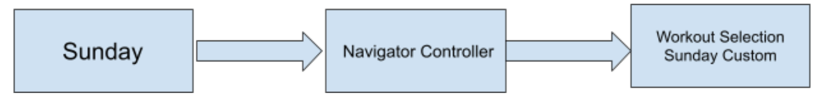

1. **Once in the Workout page, the program will provide the user with a bunch of options; First, it creates an array for the default workouts:**

* **Arm**
* **Back**
* **Shoulder**
* **Legs**
* **Core**

**Chosen a random option by the user, the program will initializes an array of options for the exercises, i.e. “pull-ups” , “Reverser cable Fly” etc..**

1. **Keep in mind that the program will also shuffle the order of the exercises using a loop and iterating through each  exercise for every time the user enters this spot in the app again.**

1. **The program repeats this process from Part 4 to each of the whichever default exercises the user chooses.**
2. **If the user wants to create his own exercise, the program makes use of the, already created, Text Field Controller, by displaying the keyboard.**
3. **Once the user clicks on the ADD button, the program automatically links and adds to the empty list displayed below the ADD button.**
4. **The program will then give the user the option to set its Sets and Reps (Repetition) for the workout it chooses and linking it again to the list.**
5. **JUST REALIZE THAT ALREADY THE PLANNER IT HAS BEEN CREATED!**
6. **The program will then, in line 86-88, create a CLEAR button that takes the workout of the steps and reps and delete the last entry.**

**Keywords the program uses:**

**Text Field Controller 2**

**Home View Controller Scene**

**Navigator Controller (How it works)..**

**Workout selection Sunday Custom.**

**Clear**

**Label 2 controller**

**Arm**

**Back**

**Shoulder**

**Legs**

**Core**

**Clear Button**

**Challenges Faced**

Not finding a C++ template to create the iOS app.  And having to figure out how to work with SWIFT was a major hurdle we had to deal with; being this a new coding language. More specific, on how we manage the interface to make it link with the code by using this new language.

Being able to communicate the ideas between all 5 members was not an easy task, when some students focus on the code, others on documentation and others on the interface. Passing along the different aspects each the coders were adding lead to force changes on those other areas.

**Why this was a good project and deserves 15% of your grade**

Learning swift, getting real world experience with app development, teaching ourselves from scratch how to make the code.

Good projects are not only based on results but in efforts and in our case, we are pretty sure we hit both. The result was simple and obvious, a practical and useful planner. Maybe it does not have the fanciest feature a fitness app can have but sometimes we realize that what you really need is an organizer for your ideas in the day and just for the mere fact of creating this asset, it provides benefits to me and all my friends.

Furthermore, effort was involved throughout every process of its making. From Step #1: thinking about the idea, then finding a way to an app with no previous experience, once we had that we were heading into understanding what language to program it and understanding that the code most not be a simple code but thinking about how will look on the interface and playing with front and back end codes at the same time.